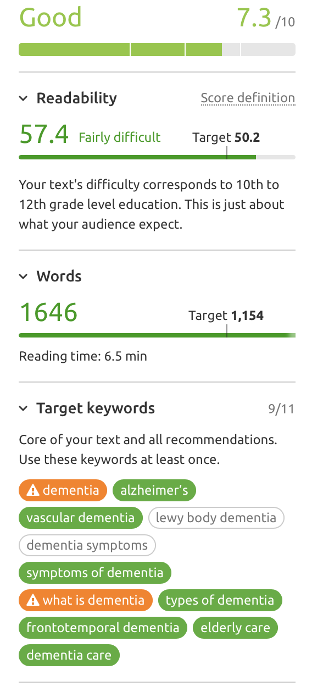 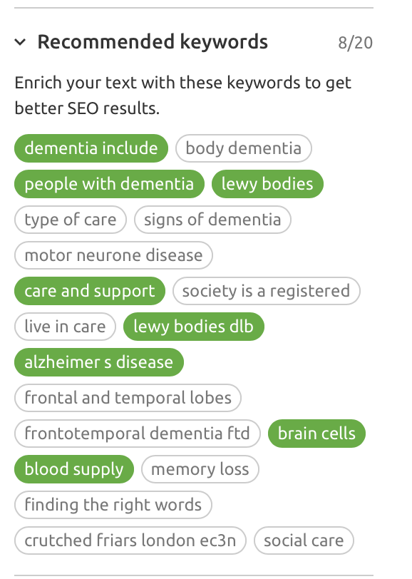

***Note Maria The two orange highlighted keywords are being used too many times… the article could be deemed as been “keyword Stuffed” you need to reduce the times these keywords are used by about 7 ort 8 occurrences each.***

*Dementia (74,000 - 41%)*

*Alzheimer’s (74,000 – 44%)*

*Vascular dementia (40,500 – 66%)*

*Lewy body dementia (18,100 – 77%)*

*Dementia symptoms (9,900 – 73%)*

*Symptoms of dementia (9,900 – 78%)*

*What is dementia (8,100 – 79%)*

*Types of dementia (6,600 – 80%)*

*Frontotemporal dementia (5,400 – 100%)*

*Elderly care (2,900 – 62%)*

*Dementia care (1,900 – 61%)*

**DEMENTIA CARE**

There is no denying that caring for a loved one with dementia can sometimes feel emotional and overwhelming. It may seem like you are spending so much time caring for your loved one’s needs that you no longer have time to enjoy their company or enjoy living your own life. It shouldn’t be like this. By letting our highly skilled and compassionate carers support your loved one in their daily routine, you can start to enjoy being a family again.

We understand that more people are choosing to stay living in their own home. We know that this is important to you and your loved one, and it is important to us. Elderly care in the home is now a realistic alternative to care homes and one that is the preferred option of many people with dementia and their family.

Whether you need a little extra help, round the clock care, or specific nursing support for complex needs, our highly skilled carers can create the right level of care for your loved one. We will take time to get to know you and your family and match you with a carer who is specifically trained and fits seamlessly into your loved one’s lifestyle. Our focus will be on helping them regain their independence and continue to live an active and fulfilled life.

Not only can we undertake the important physical tasks such as washing, dressing, toileting, administering medication and feeding, we can also fulfil the role of friend and trusted companion at times when you cannot be around. Maybe you work through the week, live far away or are planning to take a holiday? We can fill the gap, ensuring that your loved one is cared for and supported at all times.

Those who we care for are always our number one priority, giving you peace of mind that they are being taken care of and supported like a member of our own family. Our carers will not only want to know the ‘big’ things, but also the small things, like the way your loved one likes their tea, which newspaper they prefer and the names of their pets.

Whatever your needs, whether it be a short period of respite or regular support, we can tailor an elderly care package which not only suits your needs now, but continues to evolves as your loved one’s needs change. Our experienced carers are trained in a variety of specialisms including continence care, ventilator use and PEG-gastronomy.

We are also fully regulated by the CQC and directly employ all of our staff following a rigorous values-based recruitment process. This ensures consistency of carers for your loved one.

We understand that handing care of a loved one over to someone else can be an extremely difficult decision to make, but if you would like a helping hand, we would love to hear from you and to learn all about your loved one.

**WHAT IS DEMENTIA**

Dementia is the term used for many different conditions that affect the brain. The brain is made up on 8 lobes – each with its own unique function. Different types of dementia can affect different lobes, resulting in vastly differing symptoms. This is why each person with dementia can be affected in a different way.

There are currently over 850,000 people living with one of over 200 ‘sub-types’ of dementia. This number is set to rise to 1million by 2021.

This rise is put down to the fact that people are now more aware of dementia than ever before and are more likely to discuss the condition and see their GP to get a diagnosis. Also, people are now living longer with more people living into their 90s. At this age one in three people will have developed dementia.

**SYMPTOMS OF DEMENTIA**

Whatever type of dementia is diagnosed, every person’s experience and symptoms will be different. Some of the most common symptoms include:

* Delirium/Confusion
* Anxiety/Depression
* Restlessness
* Poor concentration and organizational skills
* Slow, muddled or repetitive speech
* Reduced ability to perform everyday tasks
* Distress
* Hallucinations
* False beliefs/delusions
* Failing to recognise family members
* Hearing problems

**TYPES OF DEMENTIA**

There are more than 200 ‘sub-types’ of dementia with the most well-known being Alzheimer’s Disease. Other types include Vascular Dementia, Frontotemporal Dementia, Dementia with Lewy Bodies and early-onset dementia.

Here are some of the most common types of dementia:

**Alzheimer’s Disease**

The most common type of dementia in the UK is Alzheimer’s Disease. More than 520,000 people are currently living with this form of dementia. It is named after Alois Alzheimer, the doctor who first described it. In Alzheimer’s Disease, a build-up of abnormal proteins, called ‘plaques’ and ‘tangles’, cause the loss of connections between the billions of nerve cells that connect to each in the brain. Gradually, over time, the nerve cells die, and brain tissue is lost.

**Vascular Dementia**

The second most common form of dementia is Vascular Dementia which affects about 150,000 people in the UK. Vascular Dementia is caused when diseased blood vessels reduce the blood supply to the brain. The deterioration of brain cells can cause problems with brain functions, including memory, thinking and reasoning which are known as cognition. When the effect on these cognitive functions are severe enough to have a significant impact on the person’s daily life, a diagnosis of Vascular Dementia is made.

**Dementia with Lewy Bodies**

Dementia with Lewy bodies (DLB) shares many symptoms with Alzheimer's Disease. Lewy bodies are tiny protein deposits which are found in nerve cells within the brain. Lewy bodies cause both DLB and Parkinson's Disease - two of several diseases caused by Lewy bodies. Lewy bodies affect the brain and nervous system and get progressively worse over time.

**Frontotemporal**

A wide range of conditions come under the name Frontotemporal Dementia, which is sometimes referred to as Pick’s disease or frontal lobe dementia. It is named after the frontal lobes of the brain which are damaged by this type of dementia. The frontal lobes are found behind the forehead and control behaviour, problem-solving, planning, emotions and speech.

**Mixed Dementia**

Mixed dementia signifies that a person has more than one type of dementia. The most common type of mixed dementia is the presence of both Alzheimer’s Disease and Vascular Dementia. Mixed dementia is more common over the age of 75 and at least one in 10 people with dementia will be diagnosed as having more than one type.

**Young Onset Dementia**

There are estimated to be at least 42,000 people under the age of 65 diagnosed with dementia in the UK. This equates to more than 5% of those with dementia.

**DEMENTIA DIAGNOSIS**

When people think about dementia, they often think about the later stages. But, people can live with dementia for years in the early stages, without even realising. Symptoms can often be put down to forgetfulness or ‘old age’.

If someone is showing an increase in symptoms that could be linked to dementia, it is important to visit a GP as soon as possible. There are many conditions that may look like dementia as they adversely affect memory or brain function but can be treated if diagnosed early enough.

There are many stages involved in diagnosing dementia, including looking at medical and family history and checking for underlying mental health issues or cognitive problems. It may involve blood tests, an MRI, CT scan, x-rays, or referral to a specialist for further investigation and assessment.

If, after all this, a diagnosis of dementia is given, your GP may suggest further assessments or treatments, as well as making you aware of any specialist advice and support available to you. The important thing is that you are not alone.

**CAN I AVOID GETTING DEMENTIA?**

It is not possible to avoid getting dementia, but there are things you can do to lower your risk of developing it.

The most important thing is to keep your brain healthy. Make sure you eat a balanced diet, don’t smoke, don’t drink too much alcohol, stay physically and mentally active, and make sure your cholesterol and blood pressure remain within healthy limits.

While there is currently no evidence to show that doing puzzles can improve ‘brain health’. Learning a different language is deemed to be beneficial as it stimulates different parts of the brain and can help to enhance cognitive function.

Stimulating activities, including walking, gardening, singing, art and reading, all use different parts of the brain so are also thought to help brain function.

**DEMENTIA CARE AT HOME**

Being a carer for a loved one living with dementia can be extremely demanding, especially in the later stages of their condition.

Dementia carers often experience a range of emotions – including love for the person they are caring for and the feeling that you should be caring for their every need, guilt that you cannot do more, and the feeling that you no longer have time to yourself.

In the later stages of dementia, you can feel like you no longer have your own life and cannot enjoy the time you are spending with your loved one. It can be easy to forget that you have a life too as your loved one’s needs take over you time.

It is important that you make time for yourself so that you can be in a better position to support your loved one. This can also help you to maintain a healthy relationship with each other.

Small things, like meeting friends for a coffee, taking a walk in the park, spending time on a hobby, or simply finding time to do a crossword can all help. Spending time apart from time to time can be good for both of you and help to reduce the feelings of stress you may be under.